and
Colonial Capital Williamsburg Kiwanis Foundation
BRINGS YOU WILLIAMSBURG’S 5th ANNUAL
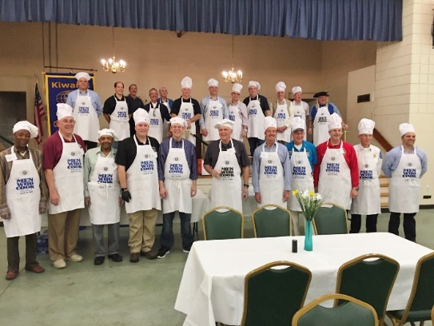

WHEN: SATURDAY APRIL 20TH, Doors open at 6PM
WHERE: Clarion Hotel Ball Room, 3032 RICHMOND RD
“YOU WON’T BELIEVE IT ‘TIL YOU TASTE IT!”
Famous LOCAL MEN, with Famous LOCAL COOKING, all HELPING LOCAL CHILDREN
Tickets: $40. 100% of the proceeds support local youth
Contact colonialkiwanis@gmail.com for tickets.

Cooks Include:
JCC Asst Administrator Brad Rinehimer, W’burg Police Chief Sean Dunn,
Dr. Charlie Frazier, Dr. Reed Hornsby, Dr. Johnstuart Guarierni,
Lt. Gen Jerry Bates USA (ret.), Vice Admiral Tom Wilson USN (ret.),
Mason School of Business Dean Todd Mooradian, Virginia State Senator Danny Diggs,
W&M Professor Dr. Randy Coleman

The Colonial Capital Kiwanis Williamsburg Foundation is a 501c (3) affiliated with the club. When you give, you support the work the Club does in our community as well the work Kiwanis does around the world. Contributions are tax deductible under section 170(b)(1)(a) of the IRS Code.

