Phase 2
The WRL Natural Playground will be constructed directly behind the James City County Library located at 7770 Croaker Rd in Toano.

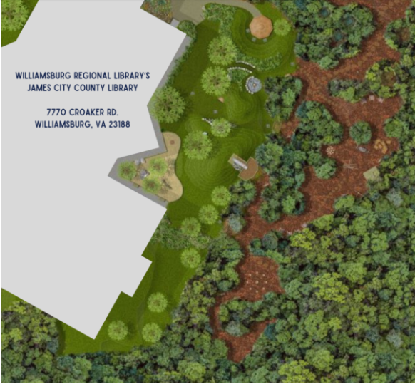

Learn about the WRL Natural Playground by visiting the library or checking out: https://wrl.org/191/WRL-Playground

Learn about the Kiwanis Kids Idea Studio by visiting:
https://wrl.org/191-Kiwanis-Kids-Idea-Studio

Info requested with each donation:

Campaign Contact (student # or last name):

____________________________
Clubs of Greater Williamsburg and James City County

Kiwanis International is a global organization of volunteers dedicated to improving the lives of children one community at a time.

For information on Kiwanis visit:
https://colonialcapitalkiwanis.org
www.facebook.com/KiwanisClubOfToano
https://williamsburgkiwanis.org
https://www.kiwanis.org

For questions concerning the Kiwanis Kids Idea Studio or the Natural Playground campaign email: colonialcapital@gmail.com

Scan the QR code to donate.


Donations of any amount are welcome!
Clubs of Greater Williamsburg and James City County

Williamsburg Regional Library

Natural Playground

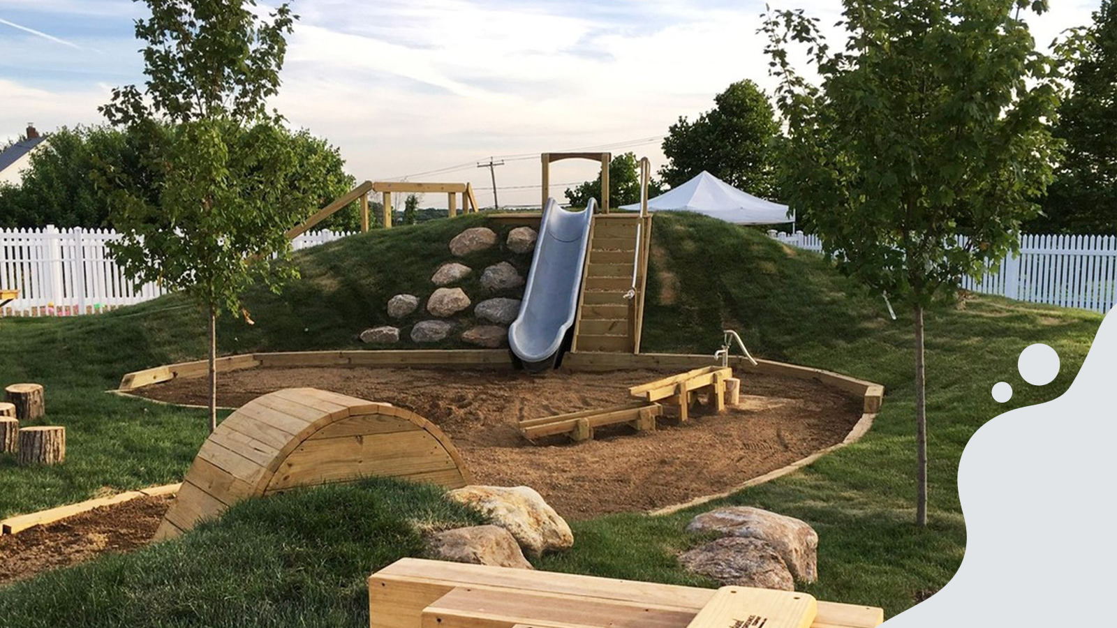
The Kiwanis clubs of Colonial Capital, Toano, and Williamsburg are raising funds to help the Friends of the Williamsburg Regional Library build a natural playground directly behind the James City County Library on Croaker Rd. The playground is Phase 2 of the Kiwanis Kids Idea Studio.

Kiwanis and Kiwanis’ Student Leadership Program (SLP) affiliates at Williamsburg area high schools are contacting local business, family, friends, and neighbors to help build the playground. Please be generous!

How Can You Help?
There is an easy way to help build the WRL Natural Playground. Donate!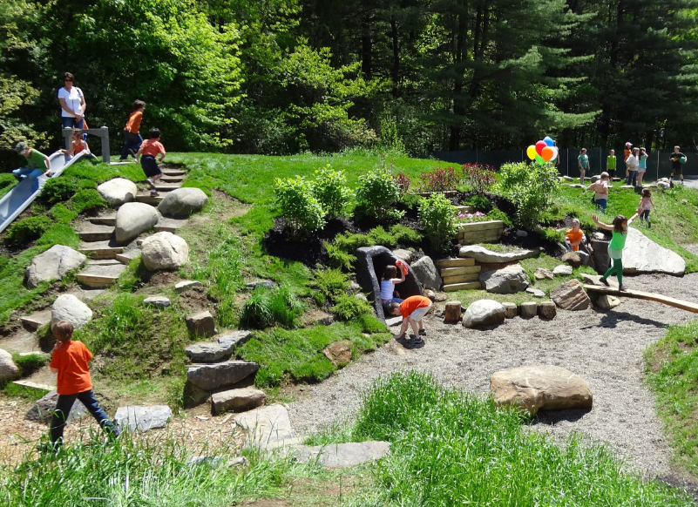 The Friends of the Williamsburg Regional Library funded the design of the Playground. Area Kiwanis clubs have made the Playground a priority and a community wide project. To demonstrate Kiwanis’ commitment, we pledged $92,000 to its construction before there was an official project. We have enlisted local high school Service Leadership Programs, e.g., Key Clubs to help fund raise, but we need your help to reach the campaign’s goal of $235,000.
Visit: https;//wrl.org/581/Gifts-for-the-Playground
To Donate

Option 1: Visit the Kids Idea Studio Natural Playground donation site. Scan the QR code or enter the donor site URL into a web browser. Both are found in this brochure. While donating or making a pledge, we ask you identify a person and organization involved in this campaign so they may be notified of your support.

Option 2: Check out a Club. Visit the website of the Kiwanis clubs supporting this effort. Learn about Kiwanis and that club’s activities and events. The site will have a link to the Natural Playground donation site. Club URLs are found on the back of this brochure.

Option 3: Visit the Kiwanis Kids Idea Studio. The Idea Studio is the best place to see how the Library, the Friends of the WRL, and Kiwanis are supporting the children of Williamsburg.

Option 4: Contact the Friends of the Williamsburg Regional Library. The Friends of the WRL were instrumental in launching the Kiwanis Kids Idea Studio and have funded the design of the WRL Natural Playground. Contact Dr. Benjamin J. Goldberg, CFRE, Library Development Officer, 757.741.3390.
Kiwanis Kids Idea Studio

In 2018, James City County approved construction of the Kiwanis Kids Idea Studio. The Idea Studio is a reimagined children’s library taking reading and play and combining them to promote learning through the stimulating fun of a children’s museum and reading library. Because of COVID, opening was delayed to June 2021 but Williamsburg and James City County families and children quickly realized learning can be fun! Compared to pre-COVID, visits are up 63% and circulation is up 71%!

Kiwanis supports the natural playground because Kiwanis believes children enjoy constructive outdoor play. The natural playground will be an exciting extension to the Kiwanis Kids Idea Studio to be enjoyed by the entire family.

